# GSM07000 – ACTIVITY APPROVAL PARAMETER

## PROGRAM DEFINITION

|  |
| --- |
|  |
| Program untuk mengatur approval activity dan numbering |

## RELATED TABLES

|  |  |
| --- | --- |
|  | **Access** |
| * GSM_ACTIVITY_APPROVAL | RW |
| * GSX_ACTAPPV_USER | RW |
| * SAM_USER | R |
| * SAM_USER_COMPANY | R |

## ROLES

|  |  |
| --- | --- |
|  | **Test** |
| * Di akses dan di atur oleh admin yang berwenang |  |

## INITIAL PROCESS

|  |  |
| --- | --- |
|  | **Test** |
|  |  |

## ACTIVITY APPROVAL

**USER INTERFACE:**



### BUTTON DEFINITION

|  |  |
| --- | --- |
|  | **Test** |
| * “**User**” – Untuk me – ‘maintain’ user dari activity approval terpilih |  |

### OUTPUT

|  |  |
| --- | --- |
|  | **Test** |
|  |  |

### ROLES

|  |  |
| --- | --- |
|  | **Test** |
| * Di isi oleh admin yang berhak mengatur activity approval |  |

### INITIAL PROCESS

|  |  |
| --- | --- |
|  | **Test** |
| * Jalankan Query ke database sebagai berikut :   EXEC [RSP_GS_GET_ACT_APPR_LIST] [Login Company Id], [Login User Id]   * Approval List:   SELECT * FROM RFT_GET_GSB_CODE_INFO('SIAPP', [Login Company Id],'_GS_APVOPTION', '', [Login Language Id]) B |  |

### DISPLAY PROCESS

|  |  |
| --- | --- |
|  | **Test** |
| * Tampilkan hasil ke dalam Grid (ready to Edit) * Disable add new dan Delete * Masukan data sebagai berikut :   + "Approval Flag"     - Combo Box     - Value = .IAPPROVAL_OPTION     - List : Approval_List     - List code = Code , List Description = CAPPROVAL_OPTION_NAME     - Enable   + "Approval Description*"     - Textbox     - Value = .CAPPROVAL_NAME     - disable   + "Approval Code"     - TextBox     - Value = .CAPPROVAL_CODE     - disable   + "Group"     - TextBox     - Value = .CAPV_LOG_GRP     - Disable   + "Update By"     - TextBox     - Value = .CUPDATE_BY     - Disabled   + "Update Date"     - TextBox     - Value = .CUPDATE_DATE     - Disabled |  |
| * Saat Button User di tekan buka tab Selanjutnya ‘Activity Approval User’ * Lempar Approval Code, approval group dan Descripotion |  |

### EDIT PROCESS

|  |  |
| --- | --- |
|  | **Test** |
| * Get Selected Dat:   EXEC [RSP_GS_GET_ACT_APPR_DETAIL] [Login Company Id], [Selected Approval Code], [User Login Id]   * Jalankan Query :   Update [GSM_ACTIVITY_APPROVAL]  Set  IAPPROVAL_OPTION = .IAPPROVAL_OPTION  ,CUPDATE_BY = {Login User Id}  ,DUPDATE_DATE = getdate()  where  CCOMPANY_ID = {Login Company Id}  and CAPPROVAL_CODE = {Selected Approval Code} |  |

## ACTIVITY APPROVAL USER

**USER INTERFACE:**



### BUTTON DEFINITION

|  |  |
| --- | --- |
|  | **Test** |
| * “**Multiple Assigment**” – Untuk me – ‘maintain’ user Secara Bulk   + On Click buka Form 3 ( Multiple Select User) secara popup   + Lempar Approval Code, approval group * “Delete User” – Untuk menghapus user yang sudah di select dari grid   + On click lakukan proses delete User |  |

### OUTPUT

|  |  |
| --- | --- |
|  | **Test** |
|  |  |

### ROLES

|  |  |
| --- | --- |
|  | **Test** |
| * Di isi oleh admin yang berhak mengatur activity approval |  |

### INITIAL PROCESS

|  |  |
| --- | --- |
|  | **Test** |
| * Siapkan Penampung untuk Approval Code, approval group dan Description dari selected activity approval saat tab di panggil. |  |

### DISPLAY PROCESS

|  |  |
| --- | --- |
|  | **Test** |
| * Tampilkan textbox untuk informasi dengan data hasil lemparan.   + “Approval”     - TextBox + TextBox     - Value = .CAPPROVAL_CODE + DESCRIPTION     - Disabled * Jalankan Query   EXEC [RSP_GS_GET_ACT_APPR_USER_LIST] [Login Company Id], [Selected Approval Code], [Login User Id]   * Tampilkan hasil ke dalam Grid * Grid Ready for Add New, Delete. * Disable Edit * Masukan data sebagai berikut :   + "User Id"     - TextBox     - Value = .CAPPROVAL_USER     - Disabled   + "User Name"     - Textbox     - Value = .CUSER_NAME     - disable   + "Create By"     - TextBox     - Value = .CCREATE_BY     - Disabled   + "Create Date"     - TextBox     - Value = .CCREATE_DATE     - disabled |  |

### ADD NEW PROCESS

|  |  |
| --- | --- |
|  | **Test** |
| * Get Selected Data:   EXEC [RSP_GS_GET_ACT_APPR_USER_DETAIL] [Login Company Id], [Login Company Id], [Selected Approval User Id]   * Tampilkan input field hanya di saat add   + "User Id"     - Combobox     - Value = **.CUSER_ID**     - Enabled     - Value = SELECT A.CUSER_ID, A.CUSER_NAME FROM SAM_USER A (NOLOCK)   INNER JOIN SAM_USER_COMPANY B (NOLOCK) ON A.CUSER_ID = B.CUSER_ID  WHERE B.CCOMPANY_ID = 'Login Company Id'  AND NOT EXISTS (SELECT TOP 1 1 FROM GSX_ACTAPPV_USER C (NOLOCK)   * + WHERE C.CAPPROVAL_USER = A.CUSER_ID)   + "User Name"     - Textbox     - Value = .CUSER_NAME     - disable   + "Create By"     - TextBox     - Value = .CCREATE_BY     - Disabled   + "Create Date"     - TextBox     - Value = .CCREATE_DATE     - disabled |  |

### Validation PROCESS

|  |  |
| --- | --- |
|  | **Test** |
| * Lakukan query :   Select  top 1 1  From  { Data di Grid }  Where  a.CCOMPANY_ID = {Login Company Id}  and a.CAPPROVAL_CODE = {Selected Approval Code}  and a.CAPPROVAL_USER = {.CAPPROVAL_USER}   * If Exists, Munculkan Error, ‘User Id already Exists for this activity approval’ |  |

### Save PROCESS

|  |  |
| --- | --- |
|  | **Test** |
| * If no error, jalankan query untuk menyimpan data.   Insert into GSX_ACTAPPV_USER  ( CCOMPANY_ID  ,CAPPROVAL_CODE  ,CAPPROVAL_USER  ,CCREATE_BY  ,CCREATE_DATE)  Values ( {Login Company Id},  .CAPPROVALCODE,  .CUSER_ID,  {Login UserId},  getdate()) |  |

### DELETE PROCESS

|  |  |
| --- | --- |
|  | **Test** |
| DELETE GSX_ACTAPPV_USER  WHERE CCOMPANY_ID = 'Login Company Id'  AND CAPPROVAL_CODE = 'Selected Approval Code'  AND CAPPROVAL_USER = 'Selected User Id' |  |
| Back to Display Process |  |

## Form 3: GSM07011 – Multiple Selection

**USER INTERFACE:**

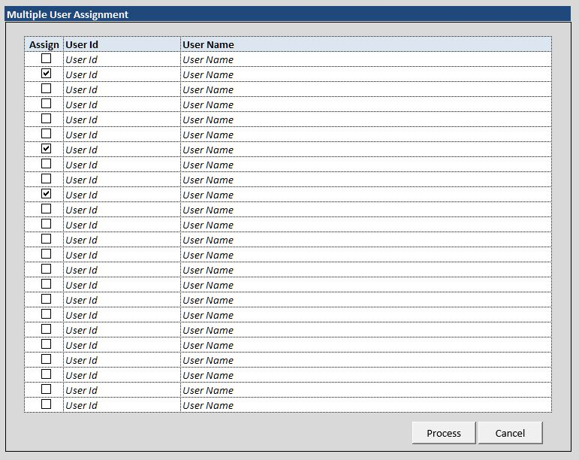

### BUTTON DEFINITION

|  |  |
| --- | --- |
|  | **Test** |
| * “Process” – Untuk mengirim data ke dalam form 2 secara bulk   + On Click jalankan “Insert process” * “Cancel” – untuk membatalkan action dan menutup form pop up. |  |

### OUTPUT

|  |  |
| --- | --- |
|  | **Test** |
|  |  |

### ROLES

|  |  |
| --- | --- |
|  | **Test** |
| * Di jalankan oleh admin yang berhak mengatur activity approval |  |

### INITIAL PROCESS

|  |  |
| --- | --- |
|  | **Test** |
| * Tamping nilai yang dilempar : Approval Code, approval group * Siapkan penampung untuk data yang terdiri dari   + LSELECTED   + CUSER_ID   + CUSER_NAME |  |

### DISPLAY PROCESS

|  |  |
| --- | --- |
|  | **Test** |
| * Jalankan Query   Select  0 as LSELECTED  ,a.CUSER_ID  ,b.CUSER_NAME  From  SAM_USER_COMPANY a (nolock)  inner Join SAM_USER b (nolock)  on a.CUSER_ID = b.CUSER_ID  Where  a.CCOMPANY_ID = {Login Company Id}  and Not Exists ( Select  CAPPROVAL_USER  from  GSX_ACTAPPV_USER c (nolock)  where  c.CCOMPANY_ID = {Login Company Id}  and c.CAPPROVAL_CODE = {.CAPPROVAL_CODE}  and c.CAPPROVAL_USER = a.CUSER_ID  )  Tampilkan hasil ke dalam Grid   * Grid Ready for Edit * Disable Add new and Delete * Get selected data:   SELECT C.CAPPROVAL_USER, B.CUSER_NAME  FROM GSX_ACTAPPV_USER C (NOLOCK)  INNER JOIN SAM_USER B (NOLOCK) ON C.CAPPROVAL_USER = B.CUSER_ID  WHERE C.CCOMPANY_ID = 'Login Company Id'  AND C.CAPPROVAL_CODE = 'Selected Approval Code'  AND C.CAPPROVAL_USER = 'Selected User Id'   * Masukan data sebagai berikut :   + "Selected"     - CheckBox     - Value = .LSELECTED     - If 0 then unchecked     - if 1 then checked     - Enabled   + "User Id"     - Textbox     - Value = .CUSER_ID     - disable   + "User Name"     - TextBox     - Value = .CUSER_NAME     - Disabled |  |

### Insert PROCESS

|  |  |
| --- | --- |
|  | **Test** |
| * Untuk setiap data where Lselected = 1,   Lakukan Insert  Insert into GSX_ACTAPPV_USER  (  CCOMPANY_ID  ,CAPPROVAL_CODE  ,CAPPROVAL_USER  ,CCREATE_BY  ,CCREATE_DATE  )  Values ( {Login Company Id},  .CAPPROVAL_CODE,  .CUSER_ID,  {Login UserId},  getdate()  )   * If no error commit else rollback * Tutup Pop Up form 3 |  |

# CR LIST

|  |  |  |
| --- | --- | --- |
| **CR** | **Description** | **Notes** |
|  |  |  |
|  |  |  |